

Faculty of Computing and Artificial Intelligence - Cairo University
DS331- System Modeling & Simulation
Course instructor:
Prof,Dr.Ayman Ghoniem

Team:
Name | ID
Ebram Samir | 20201229
Ahmed Abdelrahman Hassan | 20190046
Hossam Abdelnasser Hasssan | 20190173
Salma Ahmed | 20200223

Table of contents
Report Components
- Problem formulation & Objectives………………………………………………………………
- System Components………………………………….…………………………………………………
- System analysis including cumulative distribution tables simulation table (for 15 days) …………………………………………………………………………………………………
- Experimental Design Parameters…………………………………………………………………
- Justification of experiment parameters values………………………………………………
- Results Analysis: Using graphs & discussions stating the results……………………
- Conclusion……………………………………………………………………………………………………
Simulation Program
- Coding Style (naming convention, comments, structure) ……………………………
- GUI and Data Visualization (graphs) ……………………………………………………………
- Correct computation and results for……………………………………………………………
- The average ending units in the inventory and the showroom.…………
- The number of days when a shortage condition occurs………………………
- Do the theoretical average demands of product A and product B match the experimental ones? …………………………………………………………
- Does the theoretical average lead time of the lead time distribution match the experimental one? …………………………………………………………
- Is there a better value for the review period variable N to minimize the shortages in product A and product B? ………………………………………
- Are there better values for mA and mB to minimize the shortages in product A and product B? …………………………………………………………………
- Extra features in the simulator (for example: generic or extra statistics).………

Problem formulation & Objectives
1- Problem Formulation:
1.1 Understanding the Problem
- The electric appliance store operates a two-tier inventory system to manage products A & B efficiently:
- Showroom Inventory: Directly serves customers, max 10 units total (max 5/product). When it runs out, requests 5 units instantly from inventory.
- Main Inventory: Backup storage, max 30 units total (shared A+B). Shortages occur when cannot fulfill showroom requests.
- Inventory replenished periodically every Review Period (N=4 days). Orders subject to random Lead Times (Table 3).
- Demand varies daily per Tables 1 & 2 for products A & B.
1.2 Reformulation of the Problem
The store must optimize inventory system balancing supply-demand while minimizing shortages:
- Managing daily demand variability for two products
- Handling lead time uncertainty during restocking
- Determining optimal review period N and order quantities mA, mB minimizing shortages
- Respecting shared capacity constraints (showroom=10, inventory=30)
Simulation models interactions between showroom/inventory and assesses parameter impacts.

2. Objectives and Overall Project Plan
2.1 Main Objective
Design/evaluate multi-product inventory system minimizing shortages with capacity constraints.
2.2 Specific Objectives
- Calculate average ending showroom & inventory levels (A & B)
- Determine shortage days frequency
- Compare simulated vs theoretical demands (A & B)
- Compare simulated vs theoretical lead times
- Identify optimal review period N minimizing shortages
- Identify optimal order quantities mA, mB minimizing shortages
Is Simulation Appropriate?
- Complexity: Random demands + lead times + capacity sharing
- Scenarios Testing: Test N values & mA, mB combinations risk-free
- Cost Effectiveness: Avoids real operational disruptions
Costs and Benefits
Costs: Model development, analysis time
Benefits: Optimize policies, reduce lost sales, improve service levels
Questions to Be Answered After Finish the Simulation:
- What is average ending showroom/inventory levels?
- How often shortages occur?
- Does simulated demand match theoretical?
- Does simulated lead time match theoretical?
- What optimal review period N minimizes shortages?
- What optimal order quantities mA, mB minimize shortages?

System Components

Entities | Showroom A, Showroom B, Inventory A, Inventory B, Order System
Attributes | Current stock, Capacity Limits, Order Quantities, Lead Times
Activities | Daily Demand Calculation, Showroom Replenishment, Inventory Replenishment, Periodic Ordering, Receiving Orders.
State Variables | Showroom Stock, Inventory Stock, Order Status, Shortage indicators
Events | Daily Demand, Stockout Replenishment, Review Period Ordering, Order Arrivals

Table 1
Product A Demand (Units) | Probability | Cumulative Probability | Random-Digit Assignment
1 | 0.15 | 0.15 | 01-15
2 | 0.25 | 0.40 | 16-40
3 | 0.25 | 0.65 | 41-65
4 | 0.35 | 1 | 66-00
Table 2
Product B Demand (Units) | Probability | Cumulative Probability | Random-Digit Assignment
1 | 0.30 | 0.30 | 01-30
2 | 0.30 | 0.60 | 31-60
3 | 0.40 | 1 | 61-00
Table 3
Lead Time  (Days) | Probability | Cumulative Probability | Random-Digit Assignment
1 | 0.40 | 0.40 | 01-40
2 | 0.35 | 0.75 | 41-75
3 | 0.25 | 1 | 76-00
Calendar table (15 days)

Day | Show  Begin  A | Inven  Begin  A | Demand  A | Show  End  A | Inven  End  A | Shortage  A | Order  A | LT  A | Show  Begin  B | Inven  Begin  B | Demand  B | Show  End  B | Inven  End  B | Shortage B | Order B | LT B
1 | 5 | 15 | 2 | 3 | 15 | 0 | 0 | 0 | 5 | 15 | 3 | 2 | 15 | 0 | 0 | 0
2 | 3 | 15 | 3 | 0 | 15 | 0 | 0 | 0 | 2 | 15 | 3 | 5 | 10 | 1 | 0 | 0
3 | 0 | 15 | 1 | 5 | 10 | 1 | 0 | 0 | 5 | 10 | 2 | 3 | 10 | 0 | 0 | 0
4 | 5 | 10 | 4 | 1 | 10 | 0 | 6 | 3 | 3 | 10 | 3 | 0 | 10 | 0 | 6 | 3
5 | 1 | 10 | 4 | 5 | 5 | 3 | 0 | 0 | 0 | 10 | 2 | 5 | 5 | 2 | 0 | 0
6 | 5 | 5 | 4 | 1 | 5 | 0 | 0 | 0 | 5 | 5 | 3 | 2 | 5 | 0 | 0 | 0
7 | 1 | 5 | 4 | 5 | 0 | 3 | 0 | 0 | 2 | 5 | 1 | 1 | 5 | 0 | 0 | 0
8 | 5 | 6 | 3 | 2 | 6 | 0 | 6 | 2 | 1 | 11 | 3 | 5 | 6 | 2 | 6 | 2
9 | 2 | 6 | 4 | 5 | 1 | 2 | 0 | 0 | 5 | 6 | 2 | 3 | 6 | 0 | 0 | 0
10 | 5 | 1 | 3 | 2 | 1 | 0 | 0 | 0 | 3 | 6 | 2 | 1 | 6 | 0 | 0 | 0
11 | 2 | 7 | 4 | 5 | 2 | 2 | 0 | 0 | 1 | 12 | 3 | 5 | 7 | 2 | 0 | 0
12 | 5 | 2 | 4 | 1 | 2 | 0 | 6 | 2 | 5 | 7 | 3 | 2 | 7 | 0 | 6 | 2
13 | 1 | 2 | 2 | 2 | 0 | 1 | 0 | 0 | 2 | 7 | 3 | 5 | 2 | 1 | 0 | 0
14 | 2 | 0 | 3 | 0 | 0 | 1 | 0 | 0 | 5 | 2 | 1 | 4 | 2 | 0 | 0 | 0
15 | 0 | 6 | 3 | 5 | 1 | 3 | 0 | 0 | 4 | 8 | 2 | 2 | 8 | 0 | 0 | 0

Experimental Design Parameters
Experimental Design Parameters
- Review Period N
- Order Quantities mA, mB
- Lead Time Distribution
- Daily Demand Distributions
- Initial Levels

Why This Parameters Specially?
1. Review Period N
The review period N determines how often inventory levels are checked and replenished every N Day. It balances frequent updates to avoid stockouts with ordering costs.
2. Order Quantities mA, mB
Respect inventory constraint while matching demand patterns.
3. Lead Time Distribution
Models supply chain variability realistically.
4. Daily Demand Distributions
Reflect actual product demand patterns. Essential for realistic showroom/inventory interactions.

Results Analysis
In case of 20 Day:
- Average Showroom Ending (units): A = 2.6 units, B = 2.85 units
- Average Inventory Ending: A = 6.8 units, B = 11.15 units
- The number of days when a shortage condition occurs: A = 7 days (35%), B = 6 days (30%)
- Theoretical vs Experimental Average for demand:
Demand A: Theoretical = 2.80, Experimental = 2.75
Demand B: Theoretical = 2.10, Experimental = 2.05
The theoretical average demands of product A and B match the experimental ones.
- Theoretical vs Experimental Average for Lead Time:
Lead Time A: Theoretical = 1.85, Experimental = 2.20
Lead Time B: Theoretical = 1.85, Experimental = 1.80
Product A does not match, Product B matches.
In case of 100 Day:
- Average Showroom Ending (units): A = 2.48 units, B = 2.65 units
- Average Inventory Ending: A = 2.84 units, B = 3.77 units
- The number of days when a shortage condition occurs: A = 49 days (49%), B = 36 days (36%)
- Theoretical vs Experimental Average for demand:
Demand A: Theoretical = 2.80, Experimental = 2.85
Demand B: Theoretical = 2.10, Experimental = 2.29
Product A matches, Product B does not match

- Theoretical vs Experimental Average for Lead Time:
Lead Time A: Theoretical = 1.85, Experimental = 2.04
Lead Time B: Theoretical = 1.85, Experimental = 1.88
Product A does not match, Product B matches.
In case of 10000 Day:

- Average Showroom Ending (units): A = 2.17 units, B = 2.63 units
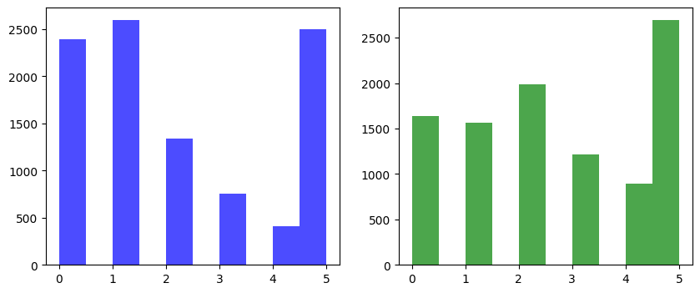

- Average Inventory Ending: A = 1.11 units, B = 4.13 units
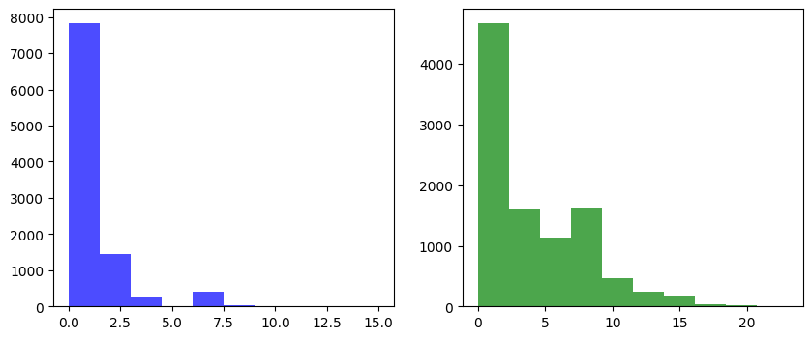

- The number of days when a shortage condition occurs: A = 5656 days (56.6%), B = 3549 days (35.5%)

- Theoretical vs Experimental Average for demand:
Demand A: Theoretical = 2.80, Experimental = 2.78
Demand B: Theoretical = 2.10, Experimental = 2.10
The theoretical average demands of product A and B match the experimental ones
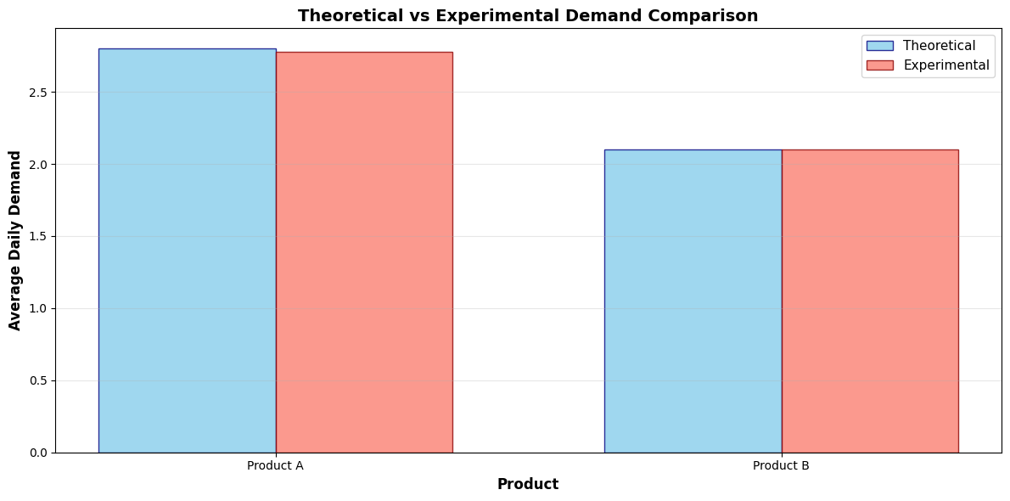
- Theoretical vs Experimental Average for Lead Time:
Lead Time A: Theoretical = 1.85, Experimental = 1.84
Lead Time B: Theoretical = 1.85, Experimental = 1.85
The theoretical average lead time of the lead time distribution match the experimental one"
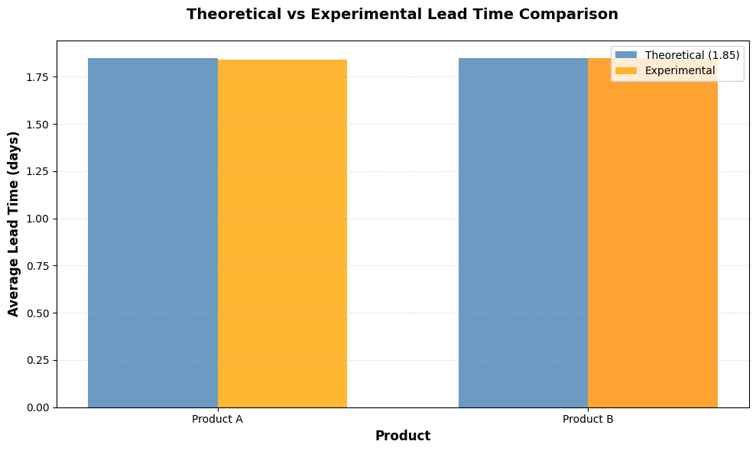
Result analysis Discussion And Conclusion:

❖ Comparison Between Theoretical and Experimental Average Demand
Results:
- Product A:
Theoretical avg demand = 2.80 units/day, Experimental avg demand = 2.78 units/day
- Product B:
Theoretical avg demand = 2.10 units /day, Experimental avg demand = 2.10 units /day
From these results, we note that the experimental demands are extremely close to the theoretical demands. This demonstrates that the simulation accurately reflects the expected demand patterns for both products, validating the random demand generation process.
❖ Comparison Between Theoretical and Experimental Average Lead Time
Results:
- Theoretical average lead time = 1.85 days
- Experimental Lead Time A = 1.84 days
- Experimental Lead Time B = 1.85 days
The experimental lead times are nearly identical to the theoretical value. This confirms that the simulation correctly captures the random variation in lead times according to the specified distribution (P(1)=0.4, P(2)=0.35, P(3)=0.25).

❖ What about the Optimal Value for the mA, mB and the N?
Current Performance Analysis
Current Parameters: N=4, mA=6, mB=6
Shortage Performance:
- Product A: Shortage occurs 5656 days (56.6%)
- Product B: Shortage occurs 3549 days (35.5%)
The high shortage frequency (56.6% for Product A) indicates that current parameters are suboptimal for the demand patterns observed.
Optimization Analysis
1. Impact of Review Period (N)
Decreasing N could reduce shortages by allowing more frequent inventory replenishments, but it would increase ordering costs.

2. Impact of Order Quantity (mA, mB)
Increasing mA, mB could help reduce shortages by providing a larger inventory buffer, but it would raise the carrying costs.

This trade-off between holding costs and ordering costs needs further investigation to find the optimal values for N and M that minimize shortages while controlling costs effectively. In conclusion, the simulation provides valuable insights into improving inventory management by identifying factors contributing to shortages and inefficiencies. Adjusting parameters like review periods or storage capacity can help reduce shortages and enhance overall system performance. The close alignment between theoretical and experimental results confirms the model’s reliability, offering a strong basis for optimizing inventory policies and ensuring better resource availability.

